
KS2 Adventurers – Summer 1

This half-termly curriculum overview provides a snapshot of what your child will be learning in school over the coming half term. It outlines the key topics, skills and areas of learning that will be covered across the different subjects. We hope it helps you understand what your child is studying and supports conversations about their learning at home.

Subject | Topic | Skills
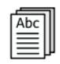 | ENGLISH  Titanic | Pupils will develop their reading and writing skills through the theme of the Titanic, exploring diaries, newspaper reports, and narrative writing inspired by the events of the voyage. They will learn to use descriptive language, structure their writing for different purposes, and write from different perspectives connected to the disaster.
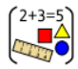 | MATHEMATICS | Pupils will prepare for upcoming assessments, revising topics:  - Area, Perimeter & Volume  - Statistics  - Shape
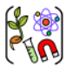 | SCIENCE  Animals including Humans | Pupils will continue to learn how the circulatory system works, including how the heart, blood, and blood vessels transport essential substances around the body. They will investigate how exercise affects heart rate, explore factors that influence healthy lifestyles, and understand how scientific evidence helps people make informed choices about their health.
 | HUMANITIES  History – Titanic  RE - Judaism: Sacred Stories and Moral Lessons | Pupils will learn about the events leading up to and during the sinking of the Titanic, including why the ship was considered “unsinkable” and what happened on its maiden voyage.  Pupils will explore Judaism through sacred stories such as those from the Torah, helping pupils understand key beliefs, values, and traditions. Pupils will be encouraged to reflect on the moral lessons within these stories.
 | ART  Titanic  DT  Textiles | Pupils will explore the Titanic through art by creating drawings, paintings, and mixed-media pieces inspired by the ship, the ocean, and the events of its voyage. They will experiment with different techniques, colours, and textures to express mood and atmosphere.  Textiles: Making SATs buddies
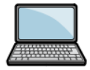 | COMPUTING
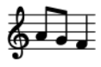 | MUSIC | Pupils will explore a range of activities, including singing, playing the keyboard, composing their own songs, and learning the ukulele, allowing them to develop skills, confidence, and a personal connection to music.
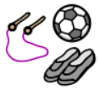 | PHYSICAL EDUCATION
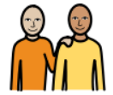 | PERSONAL, SOCIAL, HEALTH AND ECONOMIC  Healthy Me | Pupils will learn how to take responsibility for their own health, to make positive choices that benefit their health/wellbeing and become aware of different types of drugs and the effects it can have on the body.

